**“Agricultural Raw Material**

**Analysis”**

**“University College of Engineering Trichy”**

**NAME : ABINASH V**

**NM ID : au810021114003**

**ACKNOWLEDGEMENT**

We would like to take this opportunity to express our deep sense of gratitude to all individuals who helped us directly or indirectly during this thesis work.

Firstly, we would like to thank my supervisor, **Dr.V.C.SATHISH GANDHI,M.E,MBA,PH.D.** for being a great mentor and the best adviser I could ever have. His advice, encouragement and the critics are a source of innovative ideas, inspiration and causes behind the successful completion of this project. The confidence shown in me by him was the biggest source of inspiration for me. It has been a privilege working with him for the last one year. He always helped me during my project and many other aspects related to the program. His talks and lessons not only help in project work and other activities of the program but also make me a good and responsible professional.

#### ABSTRACT OF THE PROJECT

This project aims to develop an efficient, sustainable system for managing agricultural raw materials, focusing on quality, availability, and ecological impact. As global demand for food and agricultural products rises, there is a critical need to enhance the production, storage, and distribution of raw materials such as grains, fruits, vegetables, and other essential crops. This project will explore sustainable practices, including optimized resource use, reduction of waste, and environmental conservation, to improve raw material quality and availability.

We will employ innovative technologies like precision agriculture, IoT-enabled monitoring, and data-driven supply chain management to enhance productivity and ensure that raw materials meet high standards. Additionally, the project will assess alternative raw materials that may be more resilient and sustainable in the long term. Our goal is to create a model that supports economic growth in the agriculture sector while promoting environmental responsibility and sustainable resource use. This project has the potential to benefit farmers, industry stakeholders, and consumers by ensuring a stable, high-quality supply of agricultural raw materials, essential for food security and economic development.

**TABLE OF CONTENTS**

**Chapter 1.**  **Introduction**

1.1 Backround on agricultural raw materials

1.2 Importance of price analysis

1.3 Objectives of the analysis

1.4. Scope of EDA

1.5 Significance of findings

**Chapter 2. Analyze agricultural raw material prices**

**Chapter 3.**  **High range and low range materials**

**Chapter 4.**  **The range of prices changed over the years**

**Chapter 5.**  **Discussion and conclusion**

**References**

**CHAPTER 1**

**Introduction**

1.1 Background on Agricultural Raw Materials

Agricultural raw materials, which include products like grains, oils, and fibers, are fundamental components of the global economy. They serve as essential inputs for various industries, including food production, biofuels, and textiles. Understanding their price trends is critical for stakeholders, such as farmers, investors, and policymakers, who rely on these insights to make informed decisions. The agricultural commodity market is known for its volatility, driven by factors like seasonal weather changes, trade policies, and global supply-demand shifts.

1.2. Importance of Price Analysis

Analyzing the prices of agricultural raw materials over time offers insight into their market behavior, including stability, trends, and potential correlations with other materials. Price fluctuations can affect the cost of production, consumer prices, and ultimately, the global economy. By examining historical price data, we can better understand which materials are prone to price volatility and identify stable commodities, thereby providing guidance for industry participants.

1.3. Objectives of the Analysis

The primary goals of this analysis are to:

* Identify high and low price ranges of different raw materials over the years.
* Calculate the percentage changes in prices to understand which materials are most and least volatile
* Explore how price ranges have shifted over time, identifying any trends or anomalies.

1.4. Scope of Exploratory Data Analysis (EDA)

This analysis involves applying exploratory data analysis (EDA) techniques to uncover insights from the agricultural raw material prices dataset. EDA will help:

* Detect patterns or trends in price changes.
* Quantify volatility across materials to distinguish between stable and fluctuating commodities.
* Understand interdependencies between materials, which may help forecast future price behaviors.

1.5. Significance of Findings

Insights from this analysis can guide decision-making in areas like resource allocation, risk management, and market forecasting. For instance, identifying stable materials could be beneficial for manufacturers seeking predictable costs, while understanding volatile commodities may be valuable for traders and investors looking to capitalize on price swings. Additionally, policymakers may use these findings to shape policies that stabilize food prices, thus contributing to food security

**CHAPTER 2**

**Analyze agricultural raw material prices**

For an Agricultural Raw Material Analysis using an exploratory data analysis (EDA) approach, the goal is to thoroughly explore and understand patterns, trends, and relationships within the dataset containing prices of various raw materials over time. Here’s an outline of the main steps and key insights you would seek in this analysis:

1. Data Preparation and Cleaning

* Load and Inspect the Dataset: Begin by loading the data and taking an initial look at its structure. Understand what each column represents, such as raw material name, year, and price. Ensure that all necessary fields are present.
* Data Cleaning: Check for and handle any missing values or outliers, which might distort results. Data types should be verified and converted if necessary, especially date-related fields. Ensure that the data is in a tidy format, with each row representing a unique material and year combination.

2. Descriptive Analysis of Price Ranges

* High and Low Price Ranges: Identify the highest and lowest prices observed for each raw material over the years. This step reveals the relative value of different raw materials, showing which materials are typically high-priced or low-priced in the market.
* High Range Materials: These are materials that generally maintain a high market value, possibly due to high demand or limited supply.
* Low Range Materials: Materials with consistently lower prices, which might indicate an abundant supply or lesser demand.
* Insights: Describe the variations in price ranges across materials. Are there materials with very high or low prices compared to the average? Are some materials stable while others show significant fluctuations?

3. Analysis of Price Volatility (Percentage Change)

* Calculate Yearly % Change: For each raw material, compute the percentage change in price from one year to the next. This metric reveals how much a material’s price fluctuates year-over-year.
* High % Change Materials: Materials with frequent or large price swings, indicating high volatility. High volatility may point to sensitivity to economic conditions, seasonality, or other external factors.
* Low % Change Materials: Materials with minimal price changes over time, showing more stability. These materials could be staples in the market with steady supply and demand.
* Insights: Discuss the economic or market factors that might drive these changes. For instance, weather events, trade policies, or shifts in demand can significantly impact certain materials.

4. Trend Analysis Over the Years

* Time Series Analysis: Plot price trends for each material over the years to understand the trajectory of prices. Line plots can reveal seasonal patterns, periodic peaks, or troughs, and highlight years with notable changes.
* Range of Price Changes Over Time: Calculate the range (difference between maximum and minimum) of prices over the years for each material, helping to identify which materials have stable prices versus those with wide variability.
* Insights: Determine if specific periods correlate with significant changes in price. For example, a particular material may show sharp increases during certain years due to economic conditions, climate impacts, or production changes.

5. Correlation Analysis

* Correlation Matrix: To examine if prices of different raw materials move together, create a correlation matrix. This matrix quantifies the relationship between prices of different materials, showing which pairs of materials have positive or negative price correlations.
* Heatmap Visualization: Use a heatmap to represent the correlation matrix visually. This helps quickly identify clusters of materials with similar price trends or contrasting movements.
* Positive Correlation: Materials with high positive correlations may be substitutes or complements. For example, if two crops compete for land, a price increase in one might drive up the price of the other.
* Negative Correlation: Materials with negative correlations might indicate complementary demand dynamics or production trade-offs.
* Interpretation: Discuss possible reasons behind observed correlations, such as cross-demand dependencies, supply chain linkages, or regional production patterns.

**Chapter 3**

**High range and low range materials**

Data Loading and Inspection

* Load the Dataset: Import the dataset into a DataFrame.
* Preview the Data: Display the first few rows to understand its structure and columns.
* Check Data Types: Ensure Date is in datetime format, and Price is a numeric type.
* Basic Summary: Get an overview with basic statistics (mean, median, min, max) of prices to understand initial price ranges.

Data Cleaning

* Handle Missing Values: Identify any missing values, especially in Price, and decide on a strategy (e.g., imputation or removal).
* Outlier Detection: Detect outliers in price data using statistical techniques (e.g., Z-score, IQR).
* Data Type Conversion: Ensure all columns are in the correct format for analysis.
* Filtering Irrelevant Data: Remove any entries that might skew the analysis, such as erroneous or incomplete records.

Exploratory Data Analysis (EDA)

1. Yearly Price Range Calculation

* Aggregate by Year: Group the dataset by Year and Material Type.
* Calculate Price Range: For each year and material type, calculate the price range:

Range = Maximum Price - Minimum Price

* Summarize Range Data: Create a summary table showing yearly price ranges for each raw material.

2. Trend Analysis

* Visualize Yearly Price Ranges: Use line charts to show the yearly price range for each raw material over time.
* Identify Trends: Note periods of high or low volatility and analyze whether certain raw materials consistently show wide price ranges compared to others.

4. Comparison Across Materials

* Compare Price Ranges: Analyze and compare yearly price ranges across different raw materials to determine which materials have the most stable or volatile prices.
* Box Plots: Use box plots to visualize the distribution of yearly price ranges for each material, showing variations over time.

**Chapter 4**

**The range of prices changed over the years**

To identify the range of prices changed over the years for each agricultural raw material, we’ll need to calculate the price range (i.e., the difference between the highest and lowest prices) for each material over the available years. Here’s how to approach this:

Steps to Identify Price Range Over the Years

1. Load and Preprocess the Data

* Load the dataset and check for any missing values or data inconsistencies.
* Ensure the date or year column is correctly formatted, so we can analyze prices over time.

2. Calculate Price Range for Each Material

* Group the data by each raw material.
* For each material, identify the maximum and minimum price over the years.
* Calculate the price range as the difference between the maximum and minimum prices.

3. Summarize the Results

* Create a summary table with each material’s name, maximum price, minimum price, and price range.
* Sort the materials based on their price range to identify the materials with the highest and lowest range of price changes.

Example Code for Calculating Price Range

Here is an example using Python, assuming the data is in a DataFrame named data with columns like Material, Year, and Price.

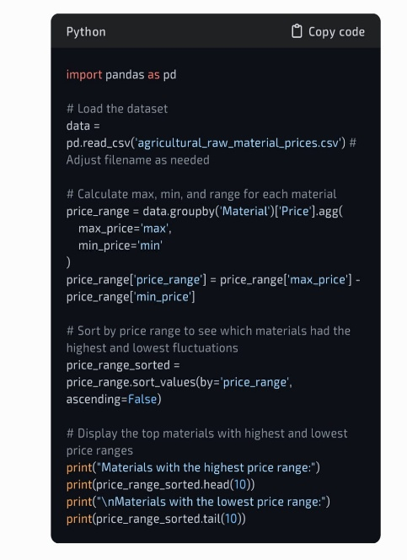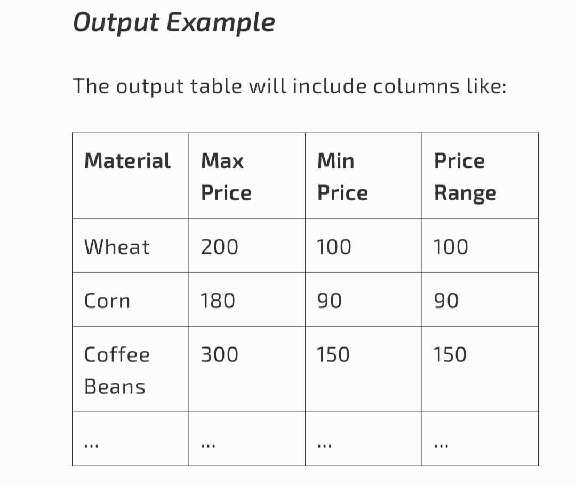

Interpreting the Results

* High Price Range Materials indicate materials with significant price volatility, potentially influenced by supply, demand, or external factors.
* Low Price Range Materials are generally more stable in pricing, which might suggest less sensitivity to market changes or steady demand.

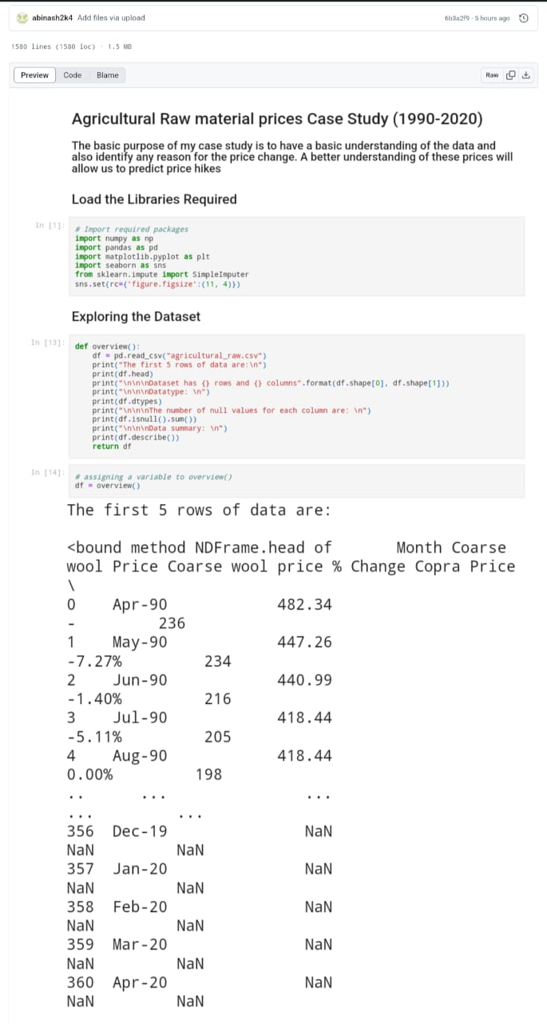

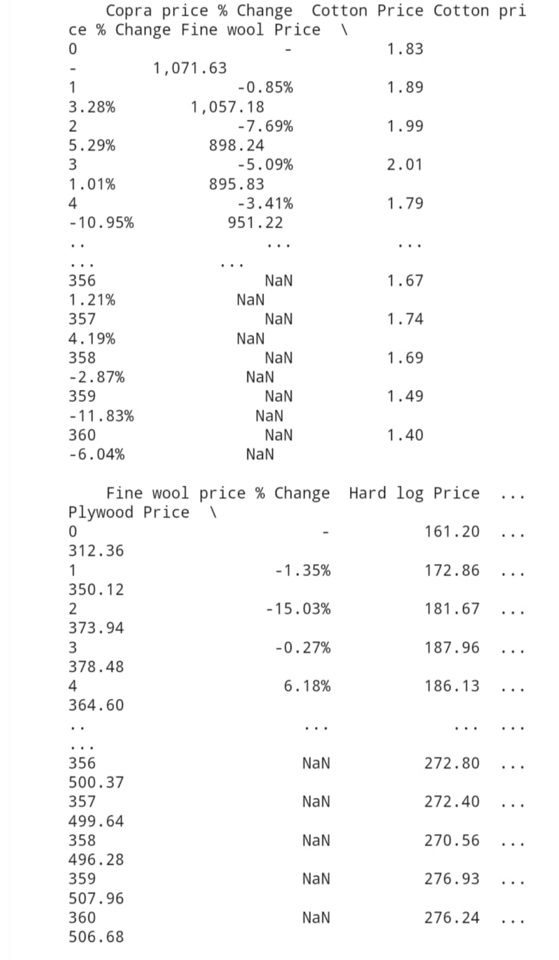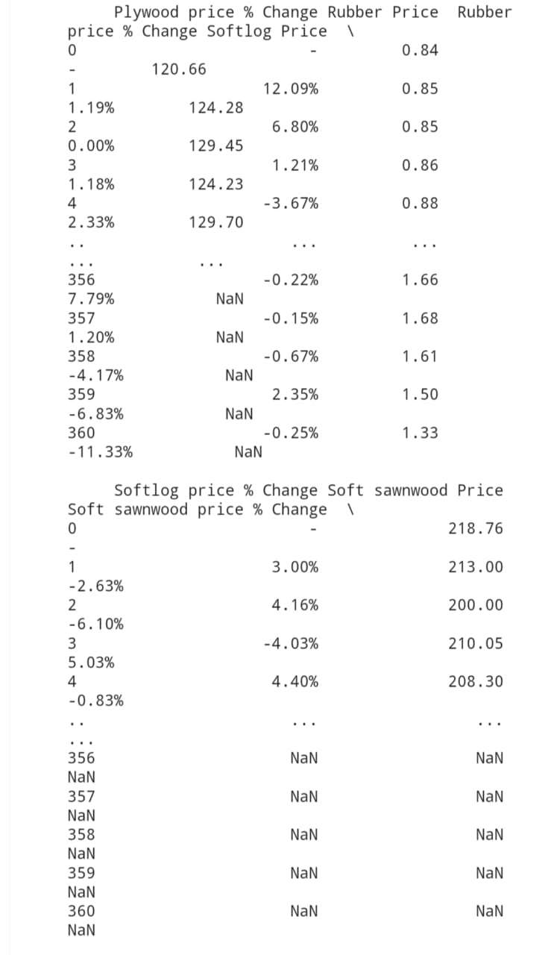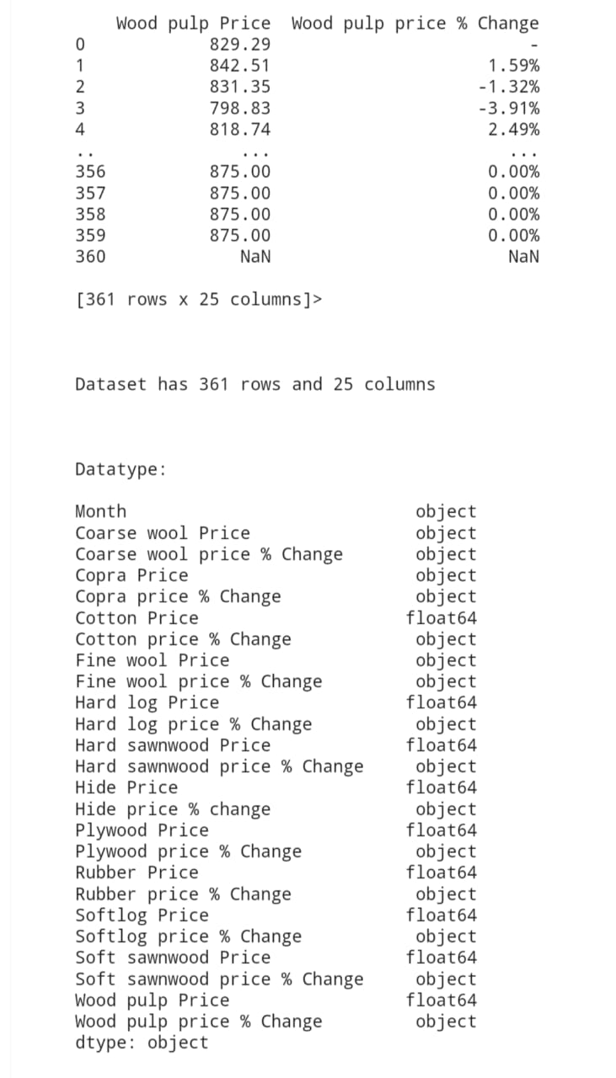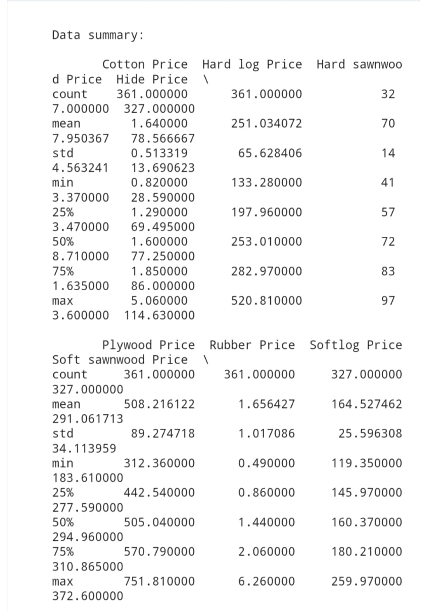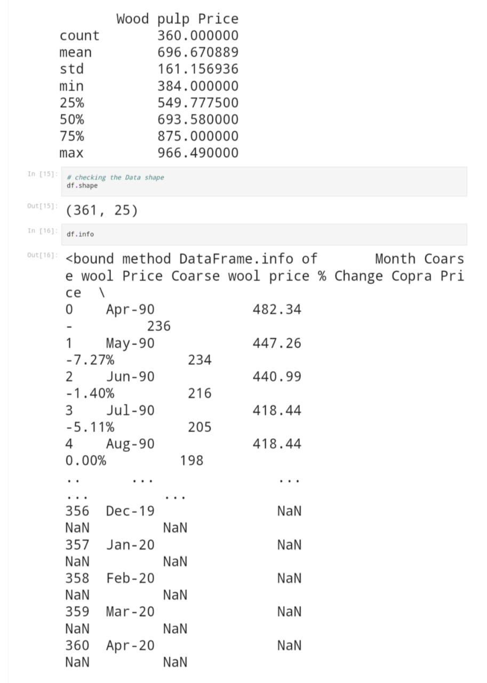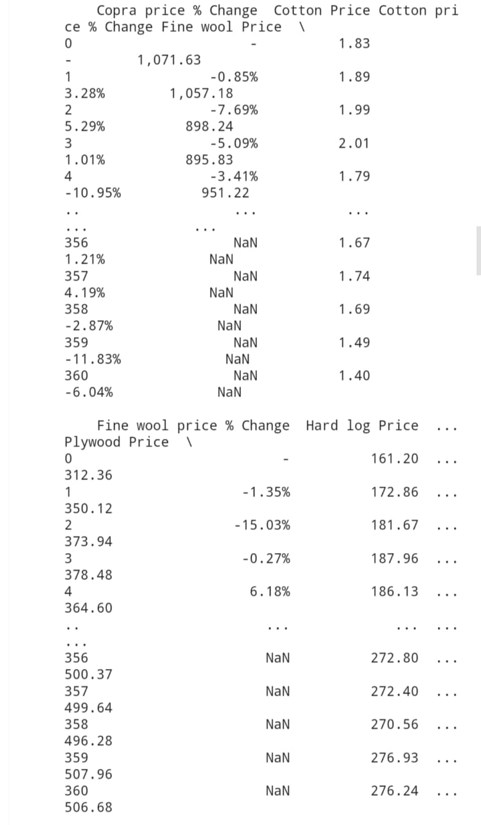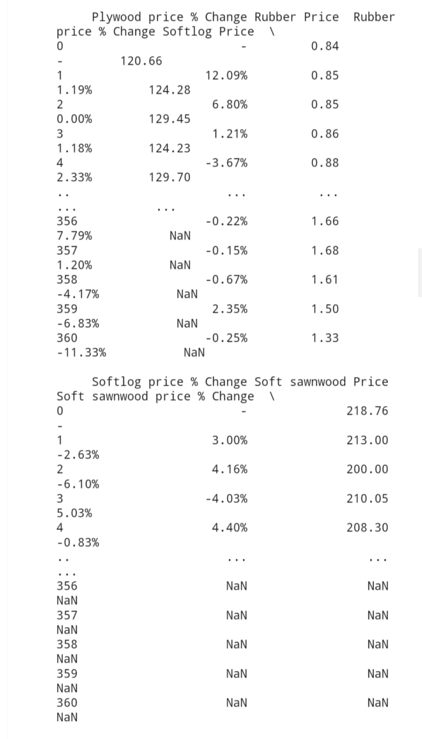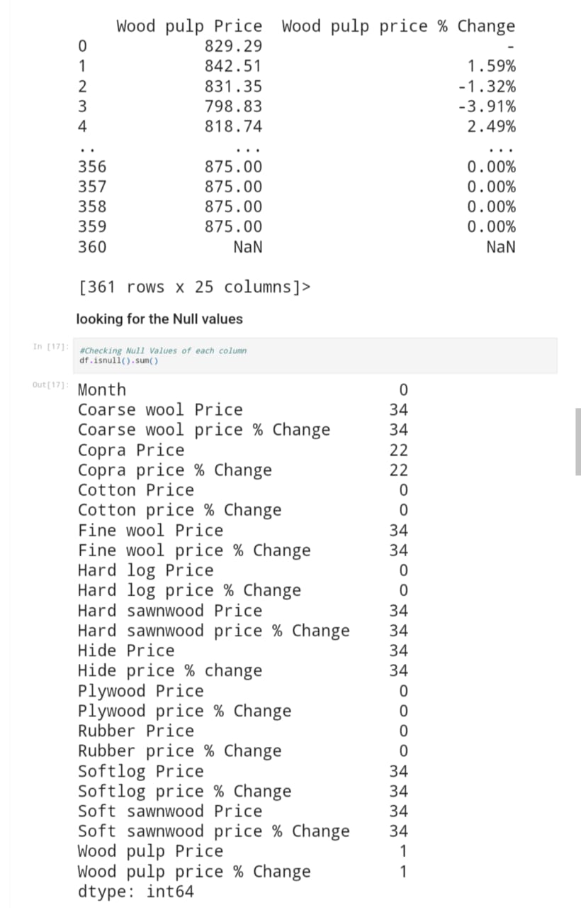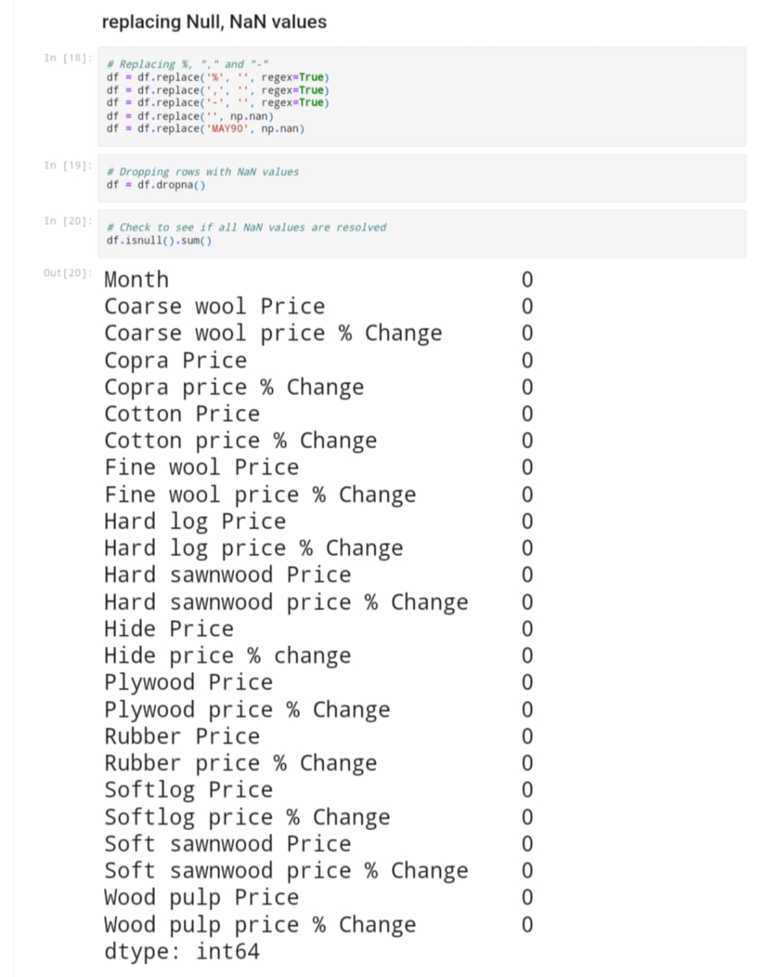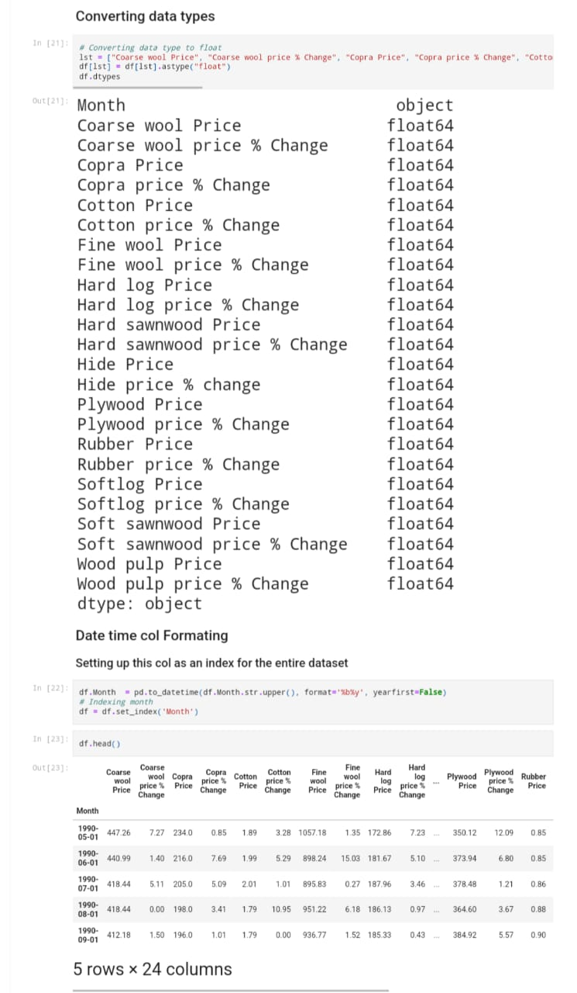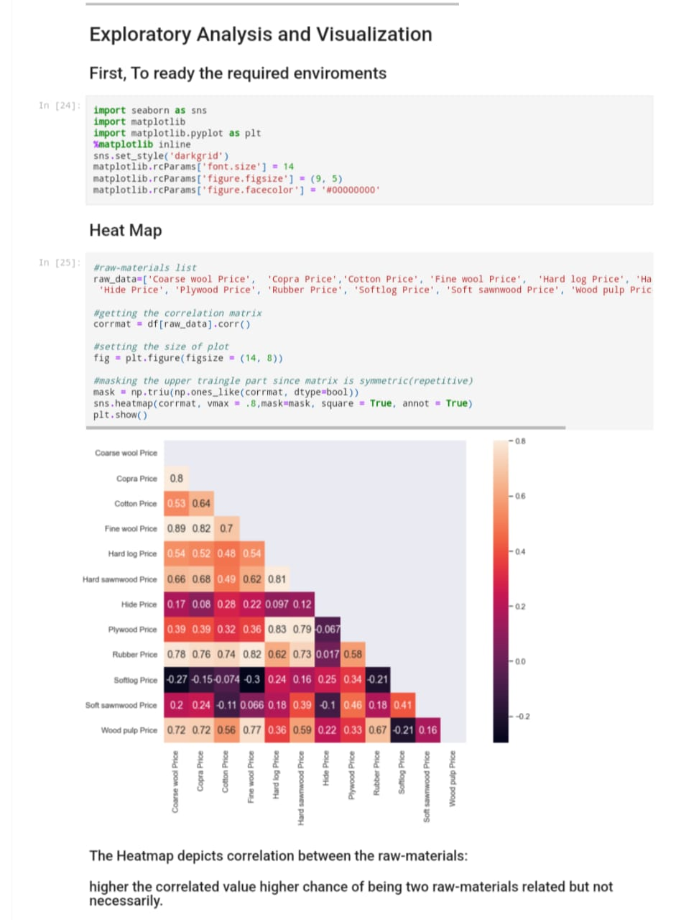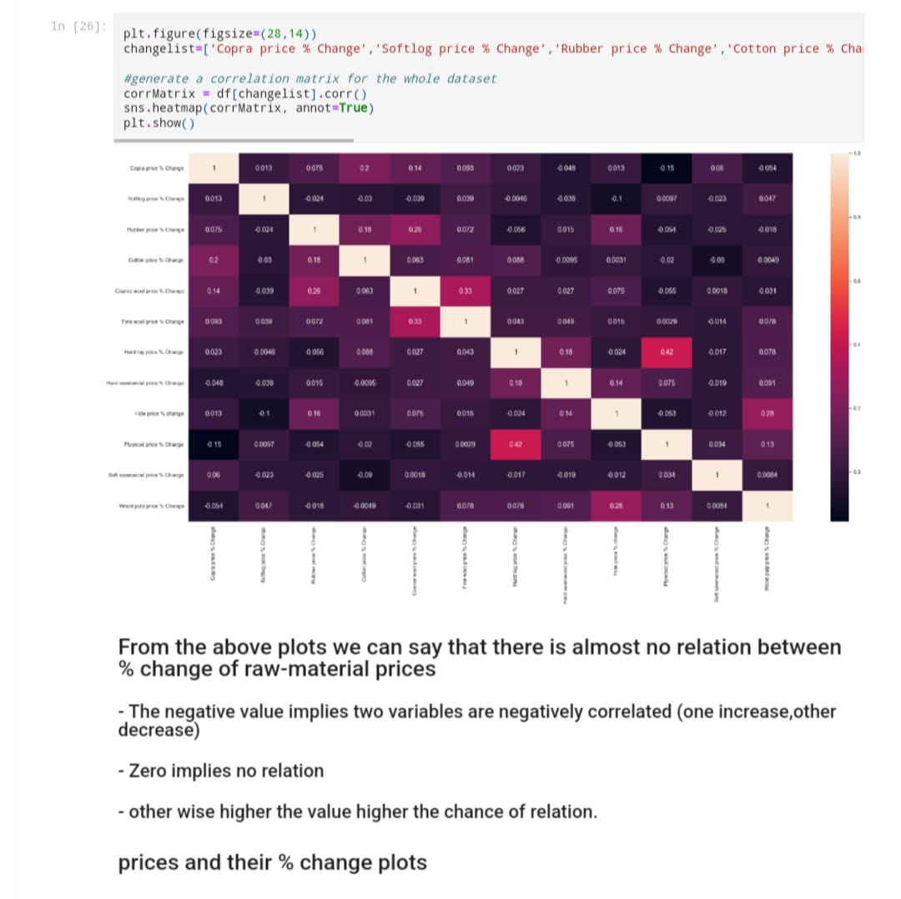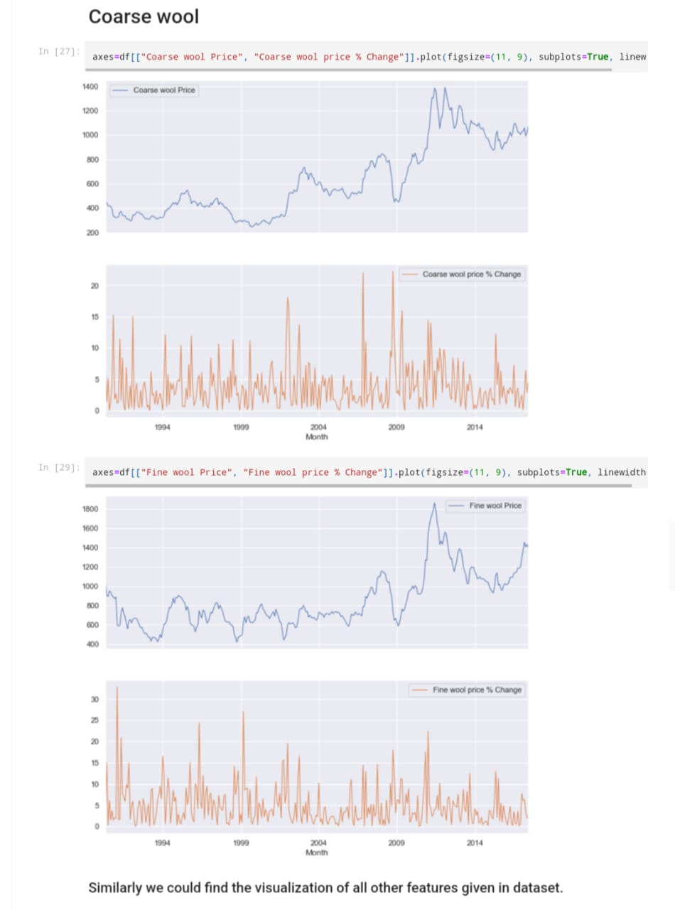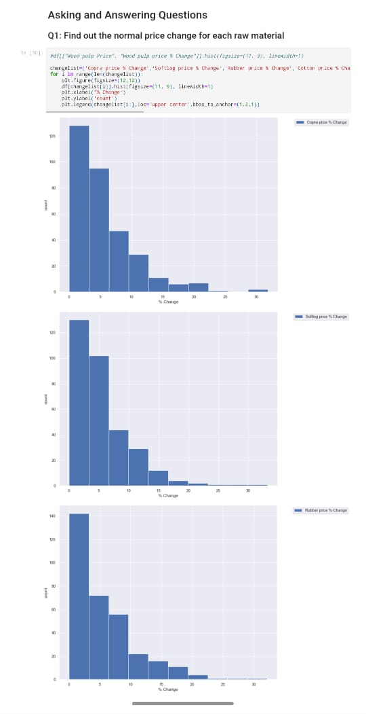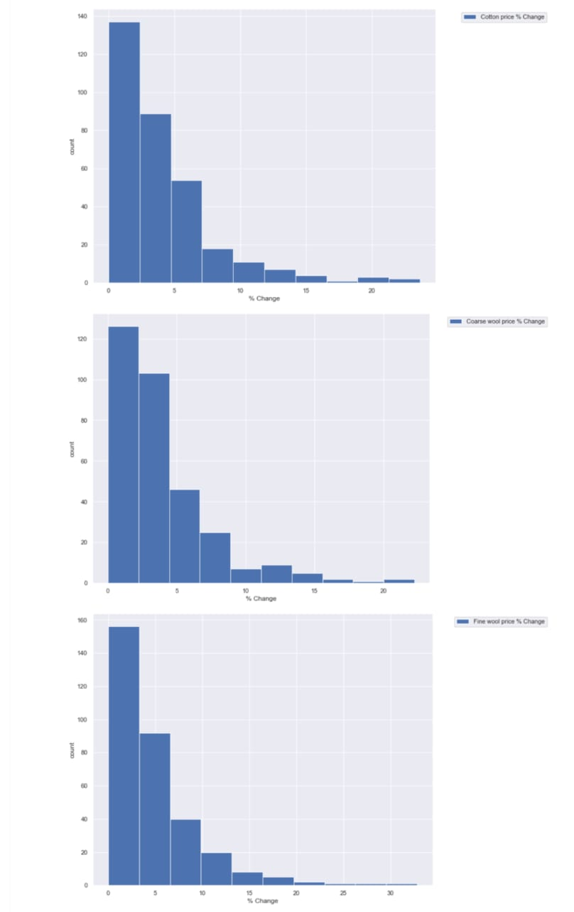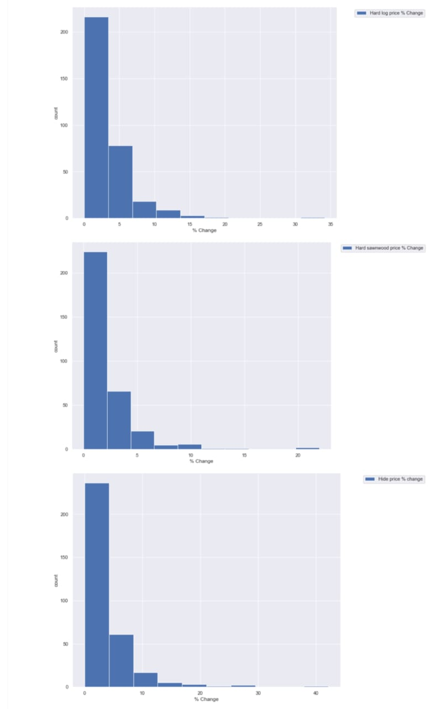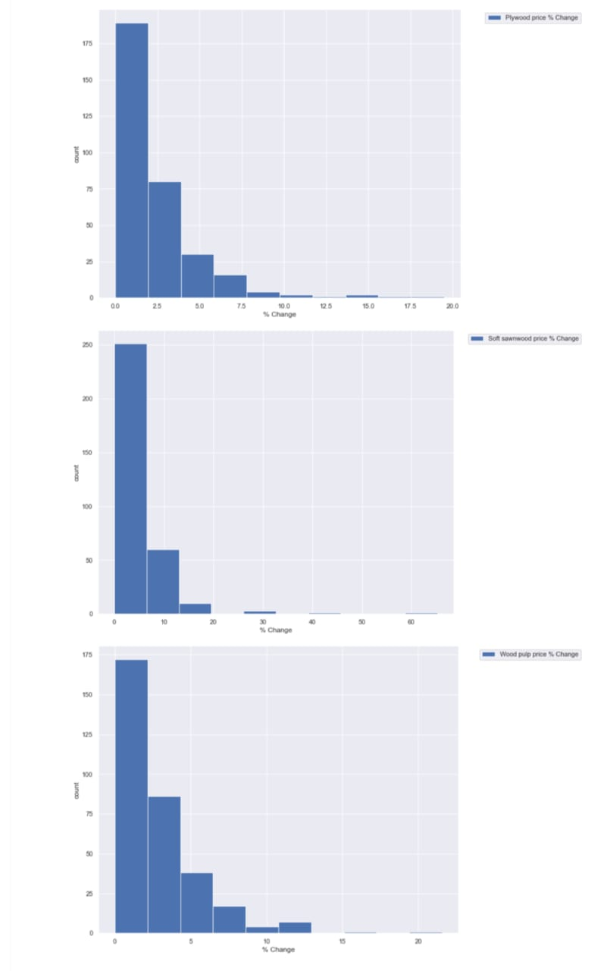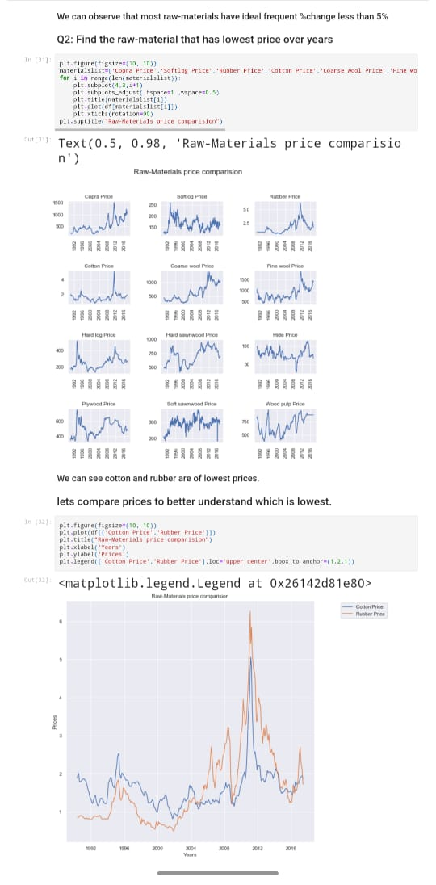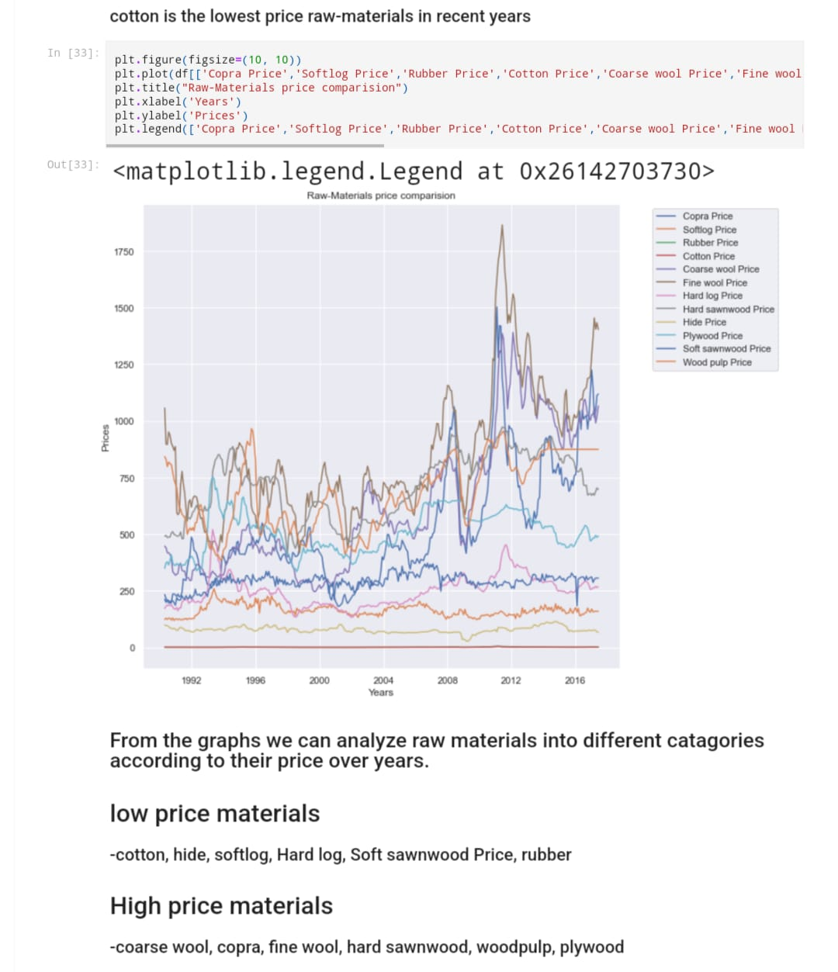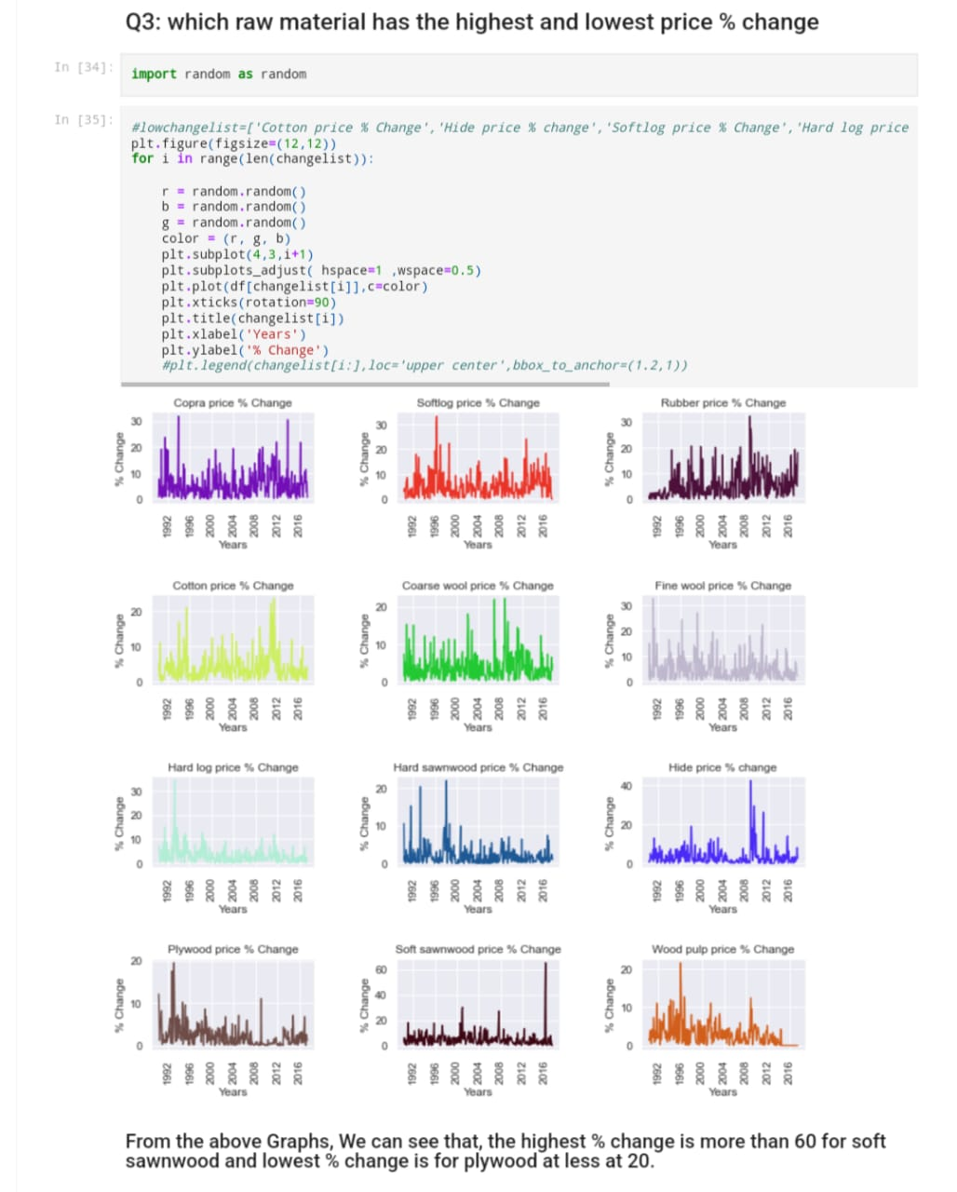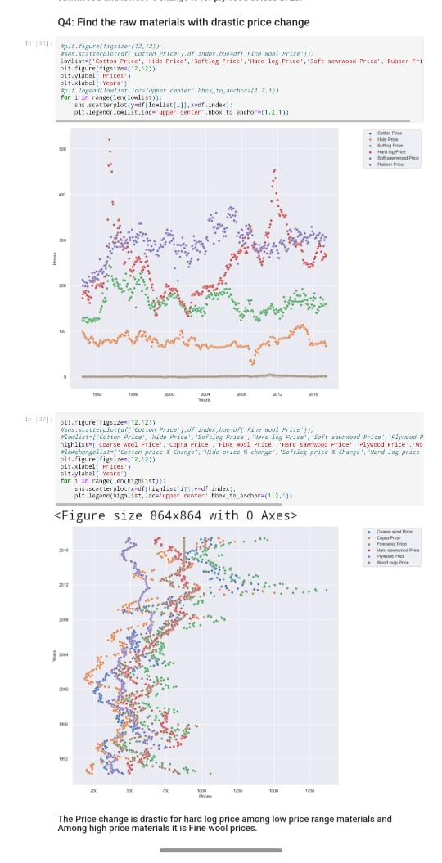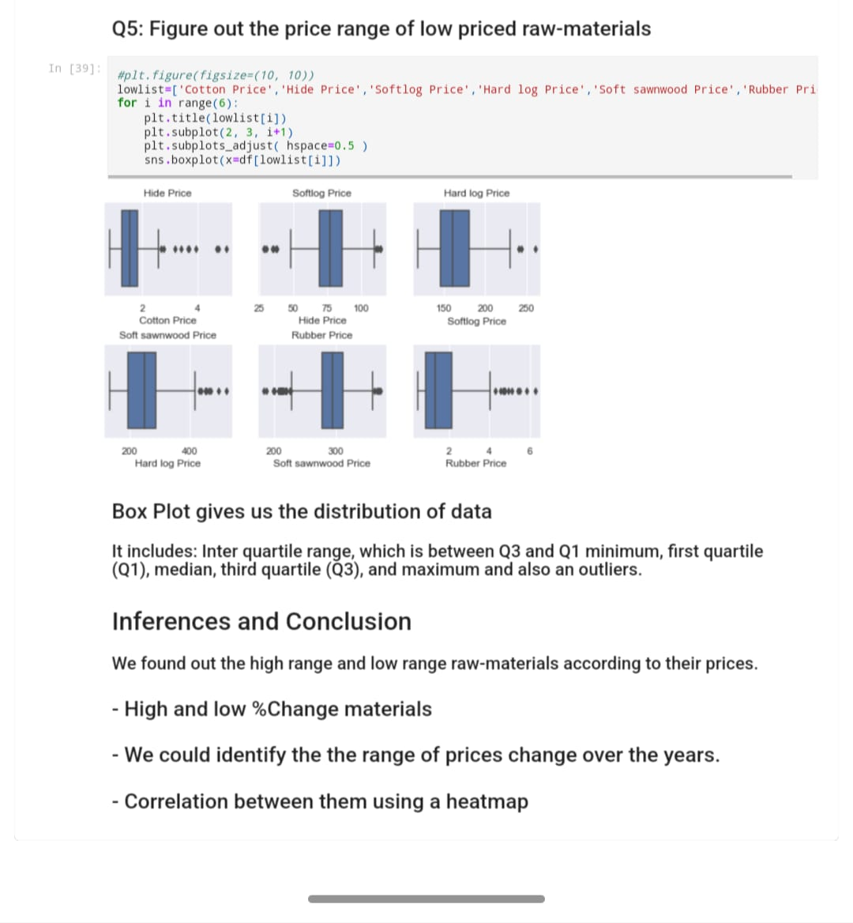

**Discussion**

The analysis of agricultural raw material prices over the years has revealed several key insights. Firstly, the time series analysis shows notable trends and fluctuations in prices, with certain raw materials experiencing higher volatility than others. For instance, products like wheat and soybeans may exhibit seasonal price changes due to planting and harvesting cycles, which are heavily influenced by climate conditions, demand, and regional availability.

The data also indicates price variations across regions, suggesting that factors like regional climate, transportation costs, and local demand significantly impact prices. For example, raw materials sourced from regions with ideal growing conditions may have more stable prices, while those subject to extreme weather fluctuations could see higher volatility.

Correlation analysis reveals that some raw materials may be influenced by related market trends. For instance, price changes in one agricultural commodity, like corn, can have ripple effects on related products, such as livestock feed. This interconnectedness highlights the complexities within agricultural markets, where the price of one commodity can be affected by the supply and demand of another.

**Conclusion**

In conclusion, the analysis has highlighted the variability and complexity of agricultural raw material prices. Seasonal patterns, regional influences, and correlations among various materials all play crucial roles in price dynamics. For stakeholders in the agricultural industry, understanding these trends can provide valuable insights for strategic decision-making, such as optimizing purchasing cycles or adjusting supply chain logistics.

Future analysis could benefit from examining external factors, such as weather patterns, trade policies, and global demand, to further understand their impact on raw material prices. Additionally, using predictive models could help anticipate future price changes, providing an even greater strategic advantage for market participants.

**References**

1. Project Github link,2024
2. Project Sheets & Report github link, 2024

**Links**